Henry KERALI

Regional Director for the South Caucasus

ECA Region, The World Bank
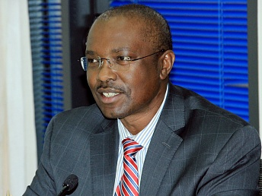

Mr. Henry Kerali was appointed World Bank Regional Director for the South Caucasus effective from July 1, 2012. Mr. Kerali has worked in different regions of the world including Latin America, Africa, East Asia, South Asia, and Europe and Central Asia (ECA). His most recent appointment was Sector Manager for Transport overseeing the Banks’ transport program in the ECA Region.
Prior to joining the Bank in 2003, Mr. Kerali was a Professor at the University of Birmingham, England, specializing in the development of transport infrastructure. He led the research to develop economic cost-benefit models for assessing the feasibility of infrastructure investments.
Mr. Kerali, a dual Ugandan and UK national, was educated in Uganda where he studied Civil Engineering. He holds an MSc and a PhD from the University of Birmingham in England. He has over 100 publications in various books, journals and Bank reports.

